Report 1 Part 1

Pool Control System

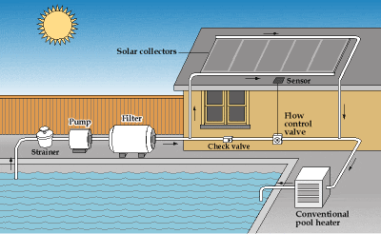

[This Photo](http://www.appropedia.org/Solar_hot_water_pools) by Unknown Author is licensed under [CC BY-SA](https://creativecommons.org/licenses/by-sa/3.0/)

Team BST – Members:

Steven Rioux

Taft Barrott

Brenton Dube

**Section I – Customer Statement of Requirements**

**Overview**

There are many individual components that make up the complete pool system. The pool system is a closed loop system with the most important part is the pool pump motor which draws pool water from the pool and forces it through the filter and other system components and back into the pool. This system must include a solar heating system control, pool motor starter, and pressure monitoring system. With a graphical user display that is easy to use and intuitive.

**The Basics**

The basic components of the system shall be:

Inputs:

* T1 – Temp sensor 1 (temp of the pool water)
* T2 – Temp sensor 2 (Temp of the roof)
* P1 – Pressure Sensor 1

Outputs:

* M1 – Motor contactor 1 for the main pump
* V1 – Valve 1, for Solar Heat
* V2 – For by pass

The system shall operate as follows, the user is allowed to enter the following Values on the graphical user display:

* Pump Start Time
* Pump Stop Time
* Target Pool Temp
* Max Pressure
* Min Pressure
* Bypass Valve Enable

Using the above information, the Pool Control Shall turn the pump M1 on at the “Pump Start Time” and turn it off at the “Pump End Time”. Anytime the Pool pump is running the pressure should always be monitored, if the pressure is detected to be greater then the “Max Pressure” It shall immediately shut the pump down and display a warning on the display. This warning shall be reset by the user only while the pump is off. The min pressure shall also be monitored, but not until after 2 minutes after the pump has turned on. If at any point passed the 2 minutes the pressure is below the “Min Pressure” setpoint the point should immediately shut down and display a warning. This would indicate a possible leak in the system.

There are 2 valves that are used in the heating system. The valves are 2 position. Valve 1 is used as a bypass valve that will when off will divert the water from the filter to the second valve when off and from the filter directly to the pool when on. The second valve V2 will direct the water from V1 to the solar heating when enabled or through the regular return path.

The bypass valve V1 shall always be in the off position unless it is selected on from the graphical user interface, if the bypass valve is on all V2 shall immediately be disabled and all heating functions shall be disabled.

The solar heating is based on several factors. When it is enabled on the user display. The control system shall monitor pool temp and roof temp. If the pool temp is below the “Target Pool Temp” and the roof temp is at least 20 degrees above the pool temp, then V2 should be enabled and the pool water shall be directed through the solar heating panels.

**Section II – System Requirements:**

The main controller system shall be a microprocessor that has Wi-Fi capability. It should have an open source firmware to allow easy adaption and future upgrades. A graphical user interface shall also be including with the design along with easy to use functions. The controller should be able to be connected to through a network connection. The user interface can be though and app or means other then an HMI.